Tower Design Input
Compilation Date: 6/07/2016

Company Name: Click or tap here to enter text.
Company Address: Click or tap here to enter text.
Contact Person: Click or tap here to enter text.
Position: Click or tap here to enter text.
E-mail: Click or tap here to enter text.
Phone: Click or tap here to enter text.
Project Name: Click or tap here to enter text.

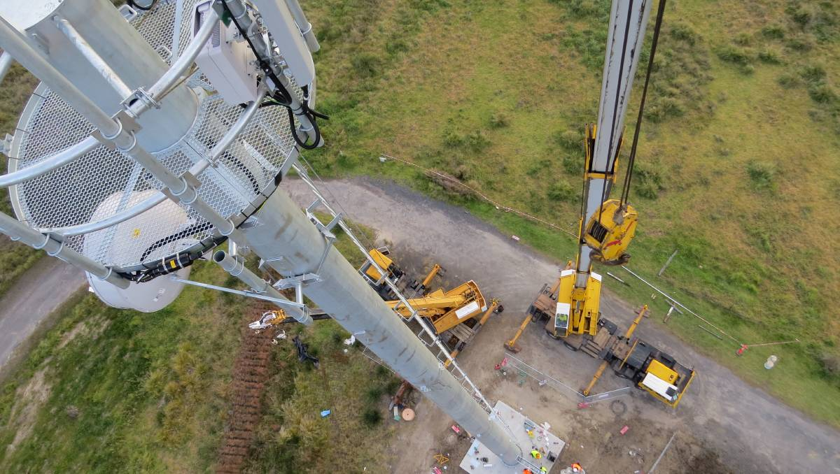

SITE INFORMATION
Location: Click or tap here to enter text.
(GPS Coordinates)

Importance Level: Click or tap here to enter text.
(1 / 2 / 4)

Terrain Category: Click or tap here to enter text.
(1 / 1.5 / 2 / 2.5 / 3 / 4)

Seismic Activity: Click or tap here to enter text.
(Yes / No)

Ice Conditions: Click or tap here to enter text.
(Yes / No)

Footing Type: Click or tap here to enter text.
(Surface Slab / Buried Slab / Bored Piers / Reaction Forces)

TOWER REQUIREMENTS
Type: Click or tap here to enter text.
(Free Standing / Guyed)

Height: Click or tap here to enter text.
(Meters)

Orientation: Click or tap here to enter text.
(e.g. One Face North / South/ East / West)

Accessories: Click or tap here to enter text.
(Ladder, Safety Climb Device, Lightning Finial, Obstruction Lighting, Headframe, Special Antenna Mount, Cable Hanger/Bracket)

Certification: Click or tap here to enter text.
(No / QLD; RPEQ / NT; Sect 40 / VIC; Cert Comp-Design / TAS; Form 55 / Industry 3rd Party / Other)

Other Loading: Click or tap here to enter text.
(Excluding Antennas)

NOTES

Location: Open cut mines or overseas locations will require a topographic map of the area within 2km radius of site for accurate wind loading assessment. Ensure scale, contour interval and grid are provided. Preferred scale is 1:25,000. Preferred contour interval is 10m.

Importance Level: 1 – Low risk of property damage or loss of life
2 – Higher risk – non habitable structures
4 – Client nominated risk (eg. post disaster)

Terrain Category: 1 – Snow
1.5 – Open Water
2 – Grassland
2.5 – Few trees, outer suburbs
3 – Trees, inner suburbs
4 – High rise buildings

Footing Type: Footing design requires a full geotechnical report including:
- Minimum recommended founding depth
- Safe allowable bearing pressure at recommended founding depth (100kPa min)
- Angle of internal friction and cohesion
- Bulk unit weight / soil density (educated estimate is appropriate)
* Bored piers require additional details.
Antenna Loading
Mount Height (m) | Mounting Orientation (Degrees Relative to True North) | Antenna Description and Size | Antenna Manufacturer | Model Number | Stand-off Distance (m) | Maximum Allowable Horizontal Deflection | Mounting Arrangements (Face Mount, Chord Mount or Clamped) | Feeder Cable Diameter
Click or tap here to enter text. | Click or tap here to enter text. | Click or tap here to enter text. | Click or tap here to enter text. | Click or tap here to enter text. | Click or tap here to enter text. | Click or tap here to enter text. | Click or tap here to enter text. | Click or tap here to enter text.
Click or tap here to enter text. | Click or tap here to enter text. | Click or tap here to enter text. | Click or tap here to enter text. | Click or tap here to enter text. | Click or tap here to enter text. | Click or tap here to enter text. | Click or tap here to enter text. | Click or tap here to enter text.
Click or tap here to enter text. | Click or tap here to enter text. | Click or tap here to enter text. | Click or tap here to enter text. | Click or tap here to enter text. | Click or tap here to enter text. | Click or tap here to enter text. | Click or tap here to enter text. | Click or tap here to enter text.
Click or tap here to enter text. | Click or tap here to enter text. | Click or tap here to enter text. | Click or tap here to enter text. | Click or tap here to enter text. | Click or tap here to enter text. | Click or tap here to enter text. | Click or tap here to enter text. | Click or tap here to enter text.
Click or tap here to enter text. | Click or tap here to enter text. | Click or tap here to enter text. | Click or tap here to enter text. | Click or tap here to enter text. | Click or tap here to enter text. | Click or tap here to enter text. | Click or tap here to enter text. | Click or tap here to enter text.
Click or tap here to enter text. | Click or tap here to enter text. | Click or tap here to enter text. | Click or tap here to enter text. | Click or tap here to enter text. | Click or tap here to enter text. | Click or tap here to enter text. | Click or tap here to enter text. | Click or tap here to enter text.
Click or tap here to enter text. | Click or tap here to enter text. | Click or tap here to enter text. | Click or tap here to enter text. | Click or tap here to enter text. | Click or tap here to enter text. | Click or tap here to enter text. | Click or tap here to enter text. | Click or tap here to enter text.
Click or tap here to enter text. | Click or tap here to enter text. | Click or tap here to enter text. | Click or tap here to enter text. | Click or tap here to enter text. | Click or tap here to enter text. | Click or tap here to enter text. | Click or tap here to enter text. | Click or tap here to enter text.
Click or tap here to enter text. | Click or tap here to enter text. | Click or tap here to enter text. | Click or tap here to enter text. | Click or tap here to enter text. | Click or tap here to enter text. | Click or tap here to enter text. | Click or tap here to enter text. | Click or tap here to enter text.
Click or tap here to enter text. | Click or tap here to enter text. | Click or tap here to enter text. | Click or tap here to enter text. | Click or tap here to enter text. | Click or tap here to enter text. | Click or tap here to enter text. | Click or tap here to enter text. | Click or tap here to enter text.
Click or tap here to enter text. | Click or tap here to enter text. | Click or tap here to enter text. | Click or tap here to enter text. | Click or tap here to enter text. | Click or tap here to enter text. | Click or tap here to enter text. | Click or tap here to enter text. | Click or tap here to enter text.
Click or tap here to enter text. | Click or tap here to enter text. | Click or tap here to enter text. | Click or tap here to enter text. | Click or tap here to enter text. | Click or tap here to enter text. | Click or tap here to enter text. | Click or tap here to enter text. | Click or tap here to enter text.
Click or tap here to enter text. | Click or tap here to enter text. | Click or tap here to enter text. | Click or tap here to enter text. | Click or tap here to enter text. | Click or tap here to enter text. | Click or tap here to enter text. | Click or tap here to enter text. | Click or tap here to enter text.
Click or tap here to enter text. | Click or tap here to enter text. | Click or tap here to enter text. | Click or tap here to enter text. | Click or tap here to enter text. | Click or tap here to enter text. | Click or tap here to enter text. | Click or tap here to enter text. | Click or tap here to enter text.

NOTES

Antenna Orientation: Identifies the physical location of the antenna on the structure
Stand Off Distance: Distance from edge of the structure out to the centreline of the antenna
Maximum Deflection: Applicable to directional antennas, particularly microwave links
Mounting Arrangements: Significant antennas such as dishes, panels and large arrays must be mounted as specified here for results to be valid

